Experiment No.8

Aim: To study, design and implement a pulse train generator using shift register.

# Objectives:

i. To study and understand working of shift register.

ii. To understand various sequence generation methods.

iii. To understand practical applications of pulse train generation.

# Equipment

Shift register (IC7475),5VDC regulated power supply, bread board, connecting wires, resistors, DMM, etc.

# Theory:

A circuit which generates a prescribed sequence of bits, in synchronism with a clock, is referred to as a sequence generator. Such sequence generators can be used as

* Counters
* Random bit generators
* Prescribed period and sequence generators
* Code generators

Practical applications of pulse train generator:

Control state counters, for stepper motor (which rotates in steps) which requires sequential pulses to rotate it from one position to the next, for biological stimulation, etc.

# Procedure:

1. Connect the components as shown in the circuit diagram.
2. Give +5V supply to the IC’s.
3. observe the outputs using LEDs.

# Logic Diagram (Design):

## SISO register.

(Here parallel o/p are also shown but we will consider the output from the last probe X1(red).)

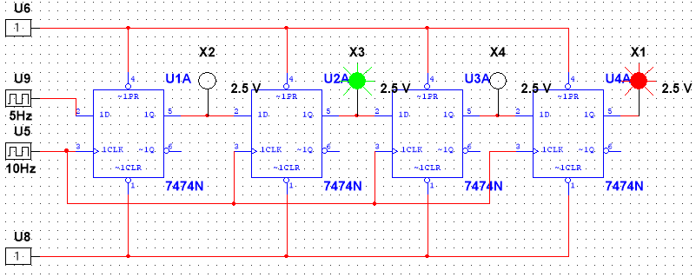

## SIPO register.

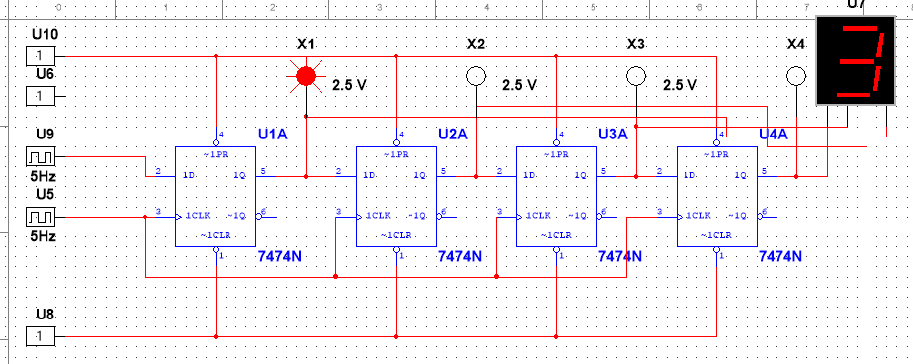

## PISO register.

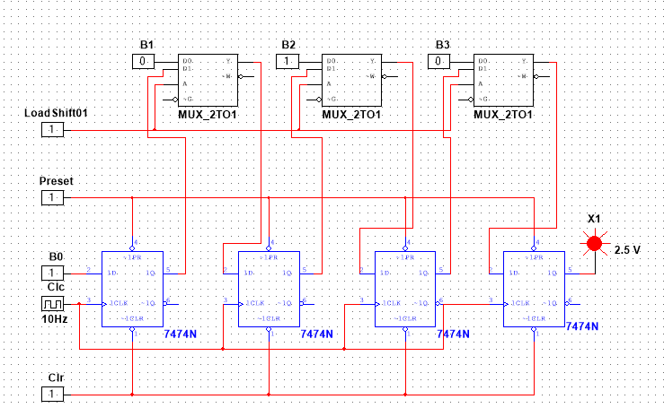

## PIPO register.

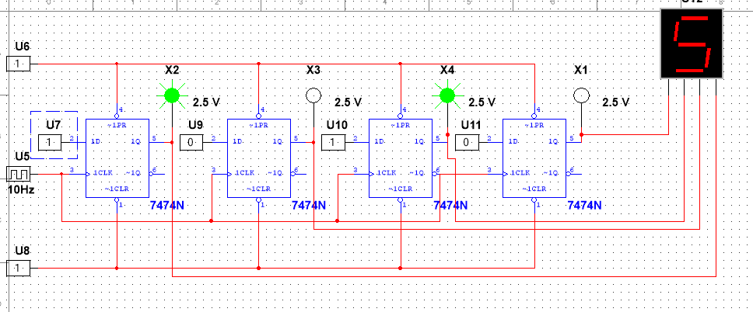

## PRNG

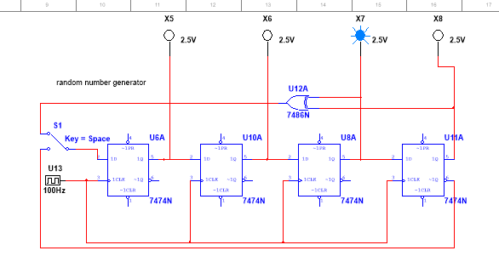

## Pulse train generator

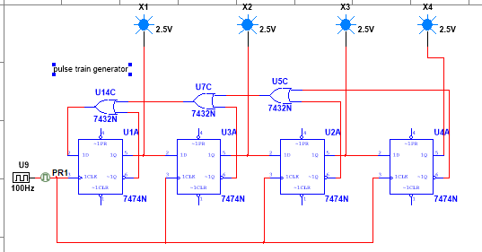

# Observations:

## PRNG and PTG

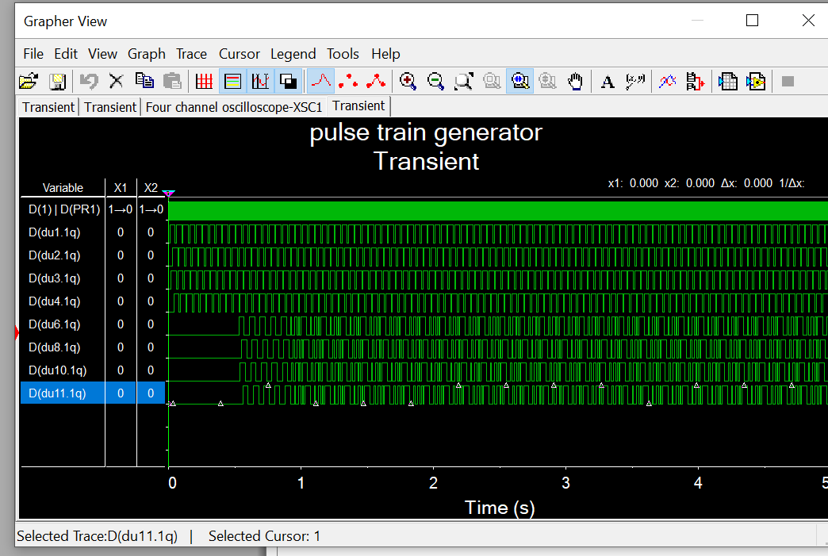

Du6 , du8, du10,du11 shows PRNG and du1-du4 shows Pulse train generator.

## Sipo register

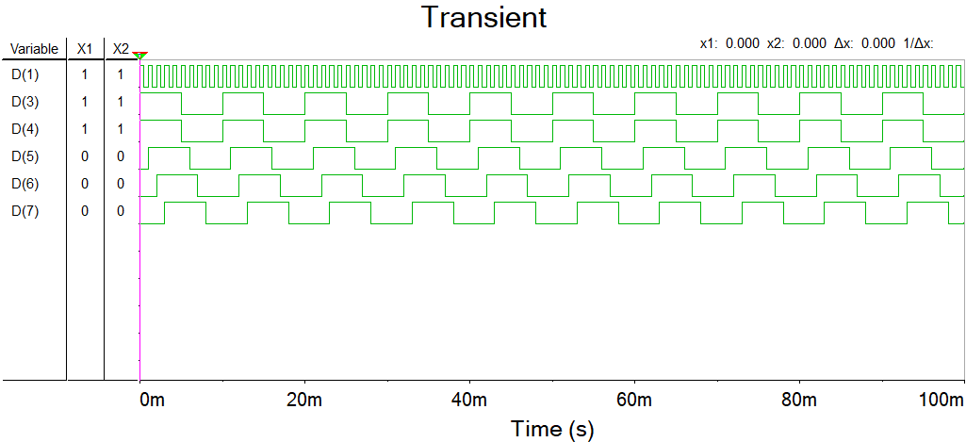

# Result:

Shift registers are used in different fashion and the obtained output shows correct and successful outcome.

# Conclusion:

As shown above the shift register can be used to store data , create pulses and create random numbers(pseudo).

# What did you learn?

I learnt SISO, PIPO methods of SR and also learnt various application of SR.

# Assignment:

Created 10bit shift register and 10bit PRNG as a project.

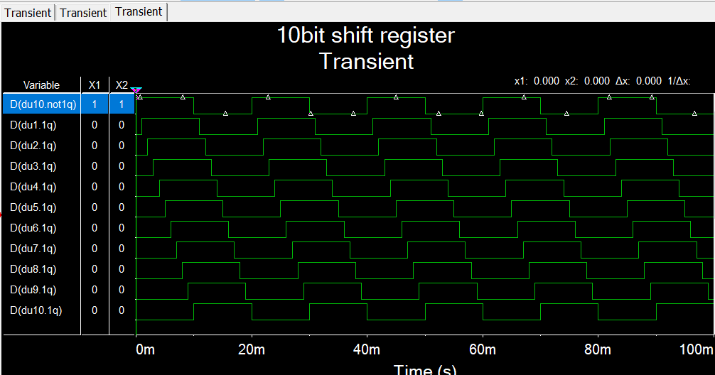

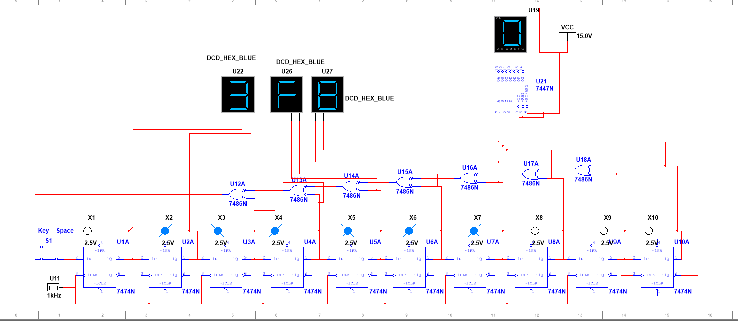

In above ckt. Switch mode: if input==10Q_not then ckt is 10bit right-handed shift register.

If input== xor feedback, then ckt is PRNG(pseudo random number generator)